|  |  |
| --- | --- |
| **Name** | Ghulam Abbas Muhammad Muneeb |
| **Reg no.** | 2018-EE-361 2018-EE-359 |
| **marks** |  |

**Experiment # 02**

**Implementation of Newton Raphson method for Multivariable System**

**Objectives:**

* + To carry out load flow analysis of the given power system network by Newton Raphson for multivariable system.

**Introduction:**

Newton Raphson Method is an iterative technique for solving a set of various nonlinear equations with an equal number of unknowns. It is one of the most important tools for determining the optimal solutions of many problems in different areas The Multi-variable Newton-Raphson method is a direct extension of the single variable Newton- Raphson method. Where the single variable Newton-Raphson method solved f (x) = 0, the multivariate version will solve a system of n equations of the form

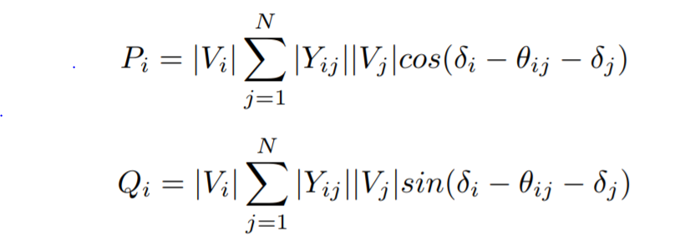

There are two methods of solutions for the load flow using Newton Raphson Method.

* + The first method uses rectangular coordinates for the variables.
  + The second method uses the polar coordinate form.

Out of these two methods the polar coordinate form is widely used.

**Task #01:**

Use Newton Raphson method to find solution of the following equation,

x12-2x1-x2=3

x12 + x22=41

#### Perform four iterations with the following initial estimation.

x1(0) = 2

x2(0) = 3

**Solution:**

A generalization of the situation we have been considering is the solution of system of nonlinear algebraic equation.

f(x) = 0

where x and f are n vectors

x = and f(x) =

**Jacobian Matrix**

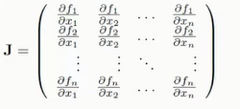

J(x(k)) δx(k) = -f(x(k))

(x(k+1)) = δx(k) + x(k)

**Theoretical Calculation:**

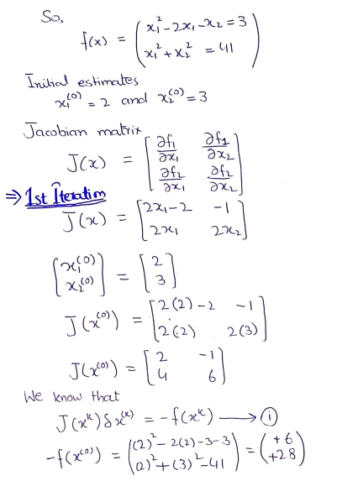

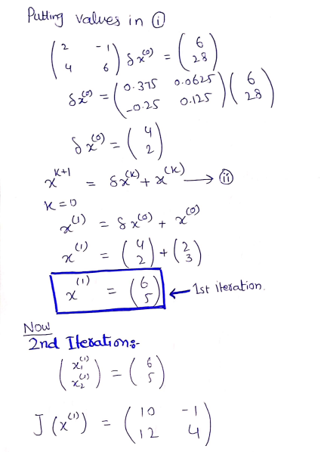

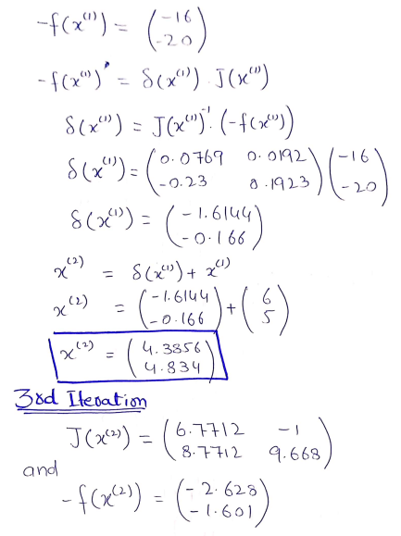

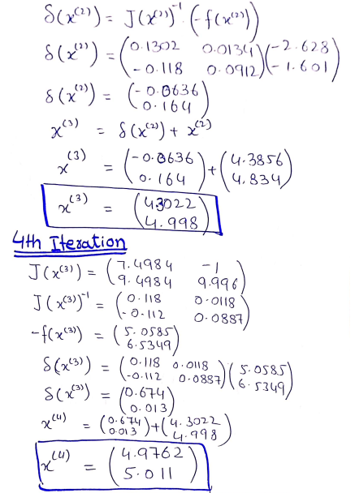

**Task #02:**

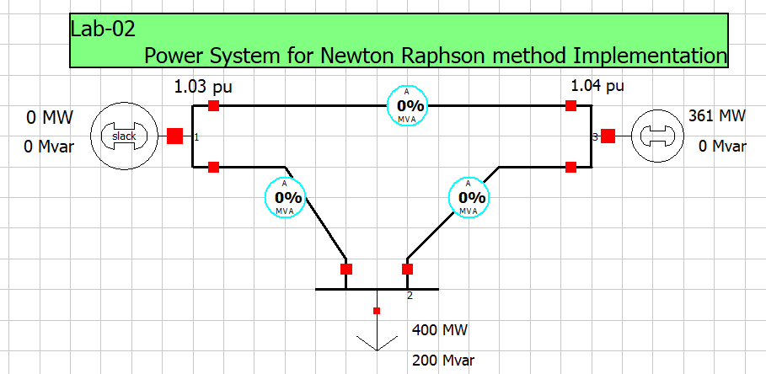

**Figure 1: Power System to be Analyze**

Figure shows the one-line diagram of a simple three-bus power system with generation at buses 1 and 3. The voltage at bus 1 is

*V*1 = 1.031 per unit

Voltage magnitude at bus 3 is fixed at 1.04 pu with a real power generation of 361 MW. A load consisting of 400 MW and 200 Mvar is taken from bus 2.

Line impedances are marked in per unit on a 100 MVA base.

* Using Newton Raphson method and initial estimates of *V*2 (0) = 1*.*0+*j*0 and *V*3 (0) = 1*.*04 + *j*0 and keeping *[V*1*]* = 1.031 pu, determine the phasor values of *V*1 and *V*3 and voltage at bus 2. Perform one iterations. (Hand Calculations)
* Also simulate the above circuit in Power World Simulator and match hand calculation with PWS obtained result

**PWS simulation:**

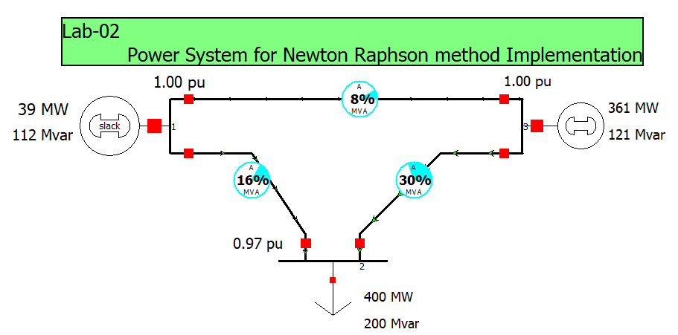

**Y-bus matrix:**

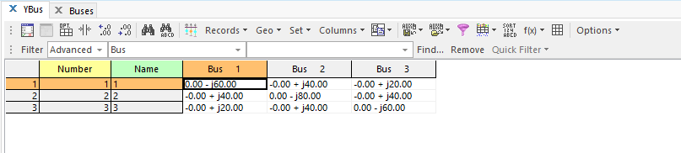

**System Information:**

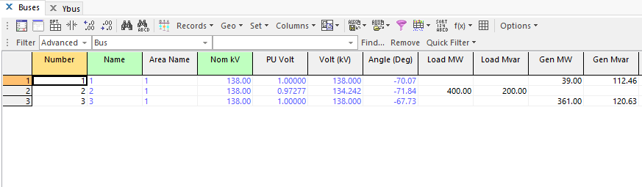

**Theoretical Calculation:**

R= 0pu X = 0.05pu (bus1-bus3) X = 0.025 (bus1-bus2 and bus2-bus3)

Y =

Y12 = -Y21 = = -40j

Y13 = -Y31 = = -20j

Y23 = -Y32 = = -40j

Y11 = Y12 + Y13= -40j – 20j = - 60j

Y22 = Y21 + Y23= -40j - 40j = - 80j

Y33 = Y31 + Y32= -20j – 40j = - 60j

By putting all values in above Ybus matrix

In polar form:

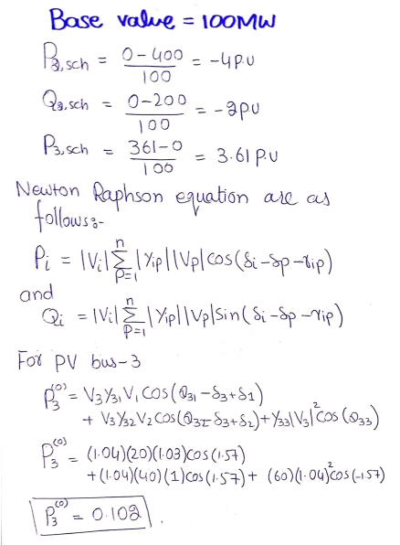

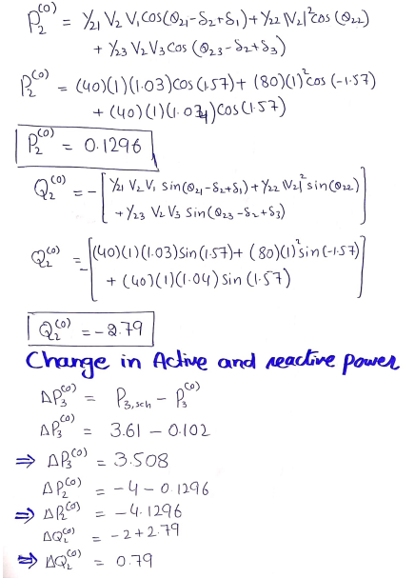

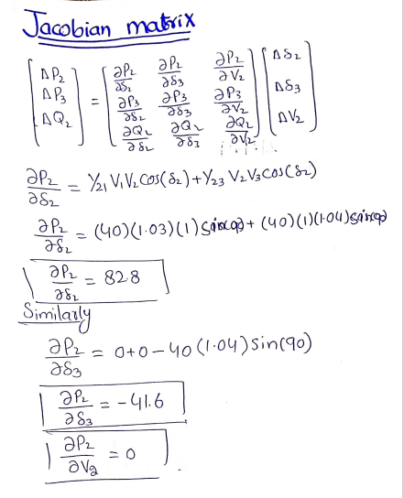

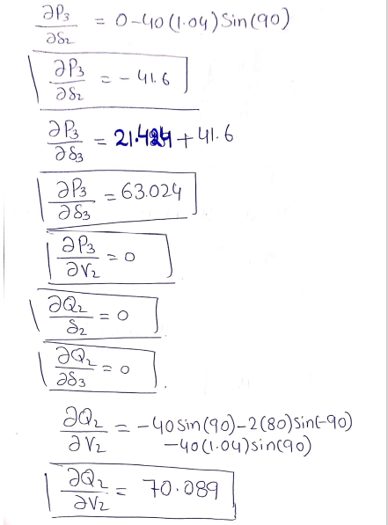

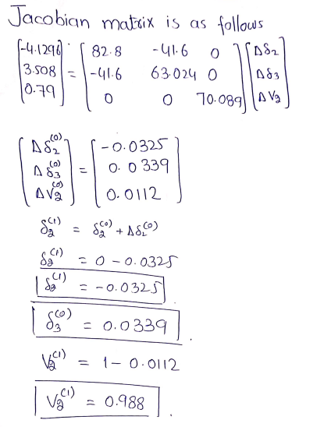

**Results:**

|  |  |  |  |
| --- | --- | --- | --- |
| **Iteration** | **Quantities** | **PWS results** | **Calculated results** |
| Initial | V10 | 1.031<00 | 1.031<00 |
| **V20** | 1<00 | 1<00 |
| **V30** | 1.04<00 | 1.04<00 |
| 1st | V1 | 1.031<00 | 1.031<00 |
| **V21** | 0.9727<-71.840 | 0.988<-0,0324rad |
| **V31** | 1.04<-67.730 | 1.04<0.0339rad |

**Learnings in Lab:**

* We learned to solve the multivariable system by using Newton Raphson method.
* We learned to implement the Newton Raphson method in load flow Analysis by theoretically and on power world simulator.
* We learned to find the unknown values of voltage and Angle of PQ bus and PV bus.
* We learned to find the unknown values of Reactive power and Angle of voltage for Generator bus or slack bus.
* We verified our results by doing theoretical calculations and then compare with software results.